Overconsumption cannot be separated from Overpopulation, together they have been exceeding our Earth's carrying capacity ever since the 1970s, a phenomenon known as Ecological overshoot which damages the environment faster than it can naturally recover.
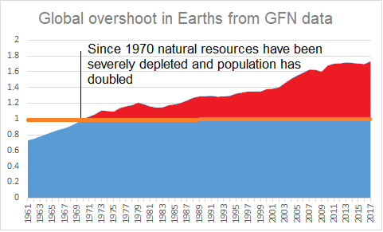
The Earth has been struggling to cope with the human population since the 1970s, the Earth Overshoot day shows how much ecological overspend we are causing, source National Footprint and Biocapacity accounts 2021. Globally we are using 1.7 of the Earth’s capacity, furthermore many scientists maintain that for a healthy ecological balance we should leave 50% of Earth’s biocapacity untouched. Additional countries available from www.overshootday.org

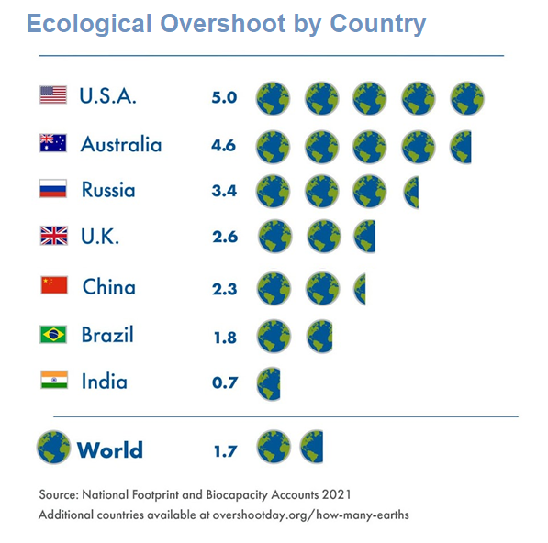
To challenge our overconsuming lifestyles a new concept has been proposed, a UN United Aspiration.
The United Aspiration seeks to inspire a new emotional maturity within the human race. The new era will be characterised by increasingly selfless behaviour both individually and collectively in the face of escalating existential threats.
Find out more at
https://poemsforparliament.uk

